Electronic Supplementary Material 1: Supplementary Information for Case Study 1

Analysis of Adjusted Pair Score for Case Study 1
In this section, we provide an analysis of the adjusted pair score for Case Study 1. Figure 2 displays a histogram of the adjusted pair score by journal. The adjusted pair scores are not normalized by the number of comparisons—since no observations were dropped—so the magnitude of the pair scores differs slightly by journal. Table 2 displays the correlations of the adjusted pair scores with the outcome for each journal. We see that the basic citation-based pair score has fairly high correlations with the outcome, ranging from 0.341 to 0.512 across the journals. The different quality-based pair scores differ substantially in their correlation with the outcome. For example, impact of results and meaningful contributions have fairly high correlations, while subfield popularity and topic popularity have fairly low correlations.

Figure 2: Histogram of Adjusted Pair Score for Case Study 1
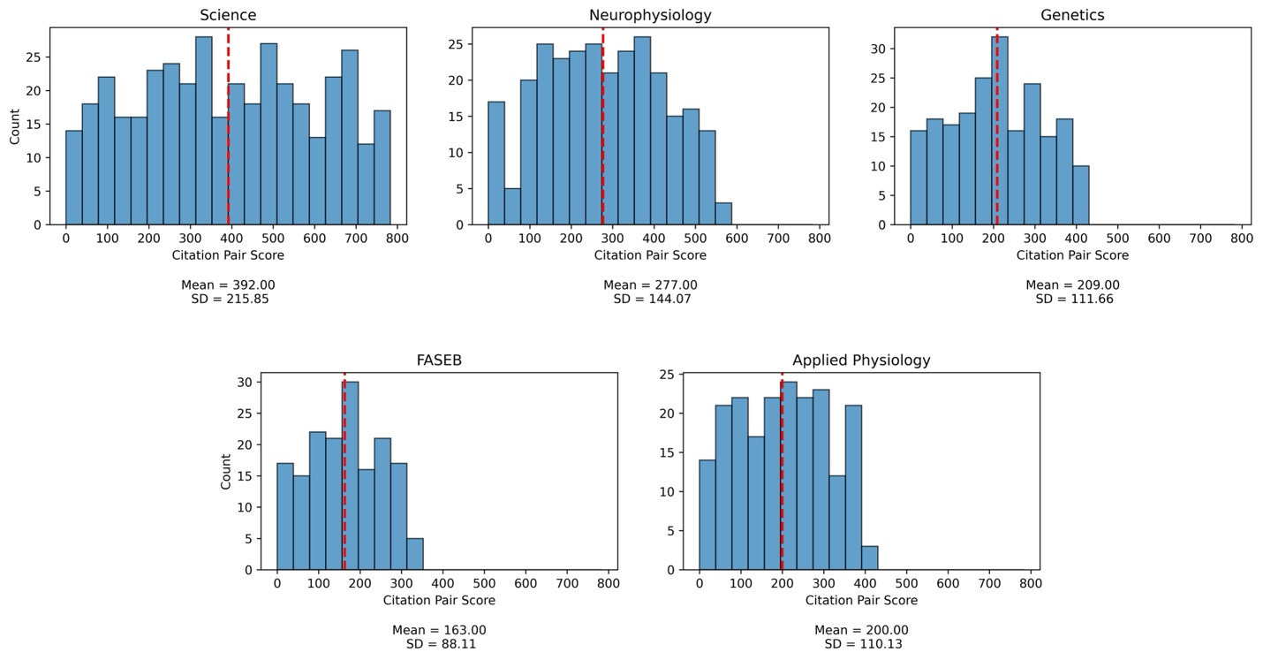

Table 2: Correlation of Adjusted Scores with Outcome
Variable | Science | Neurophysiology | Genetics | Applied Physiology | FASEB
Basic Citations | 0.482 | 0.380 | 0.341 | 0.512 | 0.408
Topic Popularity | 0.086 | 0.165 | 0.131 | 0.032 | -0.049
Title Catchiness | 0.158 | 0.278 | 0.140 | 0.258 | -0.010
Generalizability | 0.222 | 0.196 | 0.282 | 0.344 | 0.290
Writing Quality | 0.389 | 0.337 | 0.034 | 0.326 | 0.117
Impact of Results | 0.270 | 0.249 | 0.308 | 0.234 | 0.258
Subfield Popularity | -0.140 | -0.055 | 0.059 | 0.004 | -0.148
Technicality | -0.072 | -0.212 | -0.255 | -0.284 | -0.176
Meaningful Contributions | 0.221 | 0.339 | 0.330 | 0.438 | 0.204
Applicability | 0.248 | 0.115 | 0.287 | 0.132 | 0.175
Note. The first row displays the correlation of the basic “citation” pair score with the outcome for each of the five journals. The remaining rows show the correlation of each “quality” pair score with the outcome.

Additional Results for Case Study 1
In this section, we provide additional results for Case Study 1 that may be of interest to the reader. Although all our analyses for Case Study 1 are done at the journal level, we include a combined regression across all five journals for consistency with the other two case studies (Table 3). The pair scores are adjusted to account for the differing number of comparisons between each journal. We use separate random forests fit on each journal for our actual analysis (see Table 4) but include this table for consistency and to demonstrate that the basic citation score and some of the quality scores are significant. This regression suggests that all the LLM generated covariates are significant, except for topic popularity and impact of results. Table 4 displays the RMSE for different random forests fit on all observations from a single journal. Our actual random forests are leave-one-out, but we include this table to give a benchmark of the performance of those random forests. Table 5 gives the estimator standard errors by journal. These values are used to calculate the ratios in Figure 1 but we include the actual values here for reference. Table 6 reports the calculated p-values for each journal and model combinations. Only one is significant, which is to be expected for this number of p-values.
Table 3
Combined Regression Results for Case Study 1
 | Estimate | SE | p
Intercept | 21.192 | 10.826 | 0.051
Number of Authors (log) | 0.234 | 0.031 | 0.000
Number of Pages (log) | 0.248 | 0.061 | 0.000
Review Article | 0.057 | 0.090 | 0.531
Self-archived | 0.009 | 0.092 | 0.926
Basic Citation Score | 1.052 | 0.115 | 0.000
Topic Novelty Score | -45.050 | 22.889 | 0.049
Topic Popularity Score | 0.930 | 3.229 | 0.773
Title Catchiness Score | -0.420 | 0.148 | 0.005
Generalizability Score | 0.399 | 0.132 | 0.003
Writing Quality Score | 0.668 | 0.190 | 0.000
Impact of Results Score | -0.005 | 0.161 | 0.977
Subfield Popularity Score | 1.195 | 0.455 | 0.009
Technicality Score | 0.985 | 0.211 | 0.000
Meaningful Contributions Score | 0.649 | 0.269 | 0.016
Applicability Score | 0.415 | 0.179 | 0.020
Open Access | 0.048 | 0.046 | 0.299
Journal: Genetics | -0.437 | 0.069 | 0.000
Journal: Applied Physiology | -0.481 | 0.072 | 0.000
Journal: Neurophysiology | -0.377 | 0.068 | 0.000
Journal: Science | 1.518 | 0.087 | 0.000

Table 4
Random Forest RMSE by Journal and Model
Journal | Base Covariates | Base + Citation Covariate | Base + 10 Quality Covariates | All Covariates
Science | 0.8174 | 0.7624 | 0.7130 | 0.6863
Journal of Neurophysiology | 0.7021 | 0.6287 | 0.6327 | 0.6108
Genetics | 0.8081 | 0.7893 | 0.7278 | 0.7227
Journal of Applied Physiology | 0.8293 | 0.7306 | 0.7226 | 0.6867
FASEB | 0.6896 | 0.6597 | 0.6309 | 0.5972
Note. RMSEs are reported on the log scale. These are the RMSEs from random forests fit on all observations; in our analysis, we fit many leave-one-out random forests by iteratively dropping observations and fitting a random forest on the remaining data.

Table 5
Estimator Standard Errors by Journal and Model
Journal | Base Covariates | Base + Citation Covariate | Base + 10 Quality Covariates | All Covariates
Science | 0.1227 | 0.1186 | 0.1136 | 0.1011
Journal of Neurophysiology | 0.1300 | 0.1182 | 0.1132 | 0.1093
Genetics | 0.1110 | 0.1085 | 0.0985 | 0.0988
Journal of Applied Physiology | 0.1707 | 0.1786 | 0.1744 | 0.1643
FASEB | 0.1066 | 0.1027 | 0.0979 | 0.0936

Table 6
p Values by Journal and Model
Journal | Base Covariates | Base + Citation Covariate | Base + 10 Quality Covariates | All Covariates
Science | 0.152 | 0.008 | 0.286 | 0.111
Journal of Neurophysiology | 0.423 | 0.409 | 0.642 | 0.523
Genetics | 0.483 | 0.677 | 0.222 | 0.491
Journal of Applied Physiology | 0.286 | 0.358 | 0.972 | 0.787
FASEB | 0.288 | 0.099 | 0.137 | 0.145

